

Nov 26 Edition | First Name Last Name

Fall Into Savings: A Wisconsin Program That May Help With Prescription Costs
Nov  Birthdays  Birthday Here  Birthday Here  Birthday Here  Birthday Here  Birthday Here  Birthday Here  Birthday Here  Birthday Here  Birthday Here  Birthday Here  Birthday Here   | As the leaves begin to change and fall gets underway, it’s a good time to take a fresh look at your healthcare expenses — especially the cost of prescription medications.  If you are 65 or older and live in Wisconsin, you may want to learn about a state program called SeniorCare. This program may help eligible Wisconsin seniors with the cost of certain prescription medications.  What Is SeniorCare?  SeniorCare is Wisconsin’s prescription drug assistance program for residents age 65 and older.  The amount you pay depends on your annual income and the SeniorCare level you qualify for. Depending on your situation, you may have a deductible or spenddown before the program begins helping with covered prescriptions.  Could You Qualify?  For 2026, SeniorCare uses the following annual income guidelines for individuals and couples:  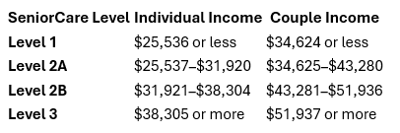  Your SeniorCare level can affect your deductible, spenddown, and prescription copayments.    To the men and women who have worn the uniform and served our country: thank you.  Thank you for the time you gave, the sacrifices you made, and the courage you showed in protecting the freedoms we enjoy every day.  We’re especially grateful for the veterans in our families, communities, and among our friends and neighbors. Each of you has a story of service and sacrifice, and we are honored to recognize you.  To every veteran: Thank you for your service, your dedication, and your sacrifice.  We are grateful for you today and every day.

Birthdays  Continued  Birthday Here  Birthday Here  Birthday Here  Birthday Here  Birthday Here  Birthday Here  Birthday Here  Birthday Here  Birthday Here  Birthday Here  Birthday Here  Birthday Here  Birthday Here  Birthday Here  Birthday Here  Birthday Here  Birthday Here   | Autumn Funnies  Page 2
 | (Please do not read if you are easily offended!)
Football Season

A grandfather and his grandson were sitting together watching football on a beautiful fall afternoon. The grandson asked, “Grandpa, have you always loved football?”
Grandpa smiled and said, “Oh yes! I’ve been watching football for many years.”
The grandson asked, “What’s your favorite part?”
Grandpa thought for a moment and said, “Sitting in my favorite chair, enjoying a bowl of chili, and having someone else bring me the snacks!”
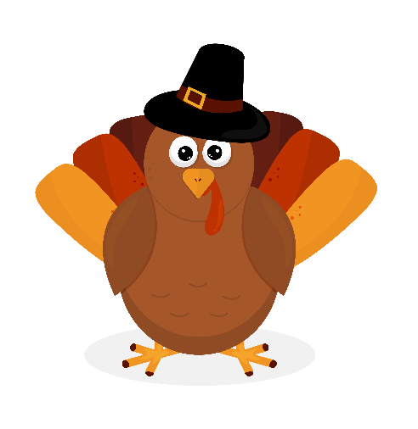
Thanksgiving Joke
A senior couple was getting ready for Thanksgiving dinner. The wife walked into the kitchen and asked her husband, “Did you remember to put the turkey in the oven?”
He smiled and said, “Of course I did!”
She looked surprised and asked, “When did you do that?”
He replied, “About three hours ago… right after I remembered where I put the turkey!”

The Fall Weather Forecast
Evelyn loved autumn. She loved the colorful leaves, the crisp mornings, pumpkin pie, and especially wearing her favorite sweaters.
One October morning, she looked outside and said to her husband, “It looks chilly today. I think I’ll wear my warm sweater.”
Her husband looked out the window and said, “It’s not that cold.”
Evelyn put on her sweater anyway. An hour later, the sun came out and it warmed up.
“I’m too hot,” she said, taking off the sweater.By lunchtime, clouds rolled in and the temperature dropped. “I’m cold again,” she said, putting the sweater back on.
Then the sun came back out. “Now I’m hot again!” Her husband finally looked at her and said, “Maybe you should just leave the sweater on the chair and move back and forth all day.”
Evelyn laughed and said, “That’s exactly what I’ve been doing with the thermostat for the last 20 years!” They both agreed that fall weather was beautiful—but it certainly couldn’t make up its mind!
The best thing about autumn? You never know what you’re going to get… so just bring a sweater!

Birthdays  Continued  Birthday Here  Birthday Here  Birthday Here  Birthday Here  Birthday Here  Birthday Here  Birthday Here  Birthday Here  Birthday Here  Birthday Here  Birthday Here  Birthday Here  Birthday Here  Birthday Here  Birthday Here  Birthday Here  Birthday Here | Fun Page | Page 3
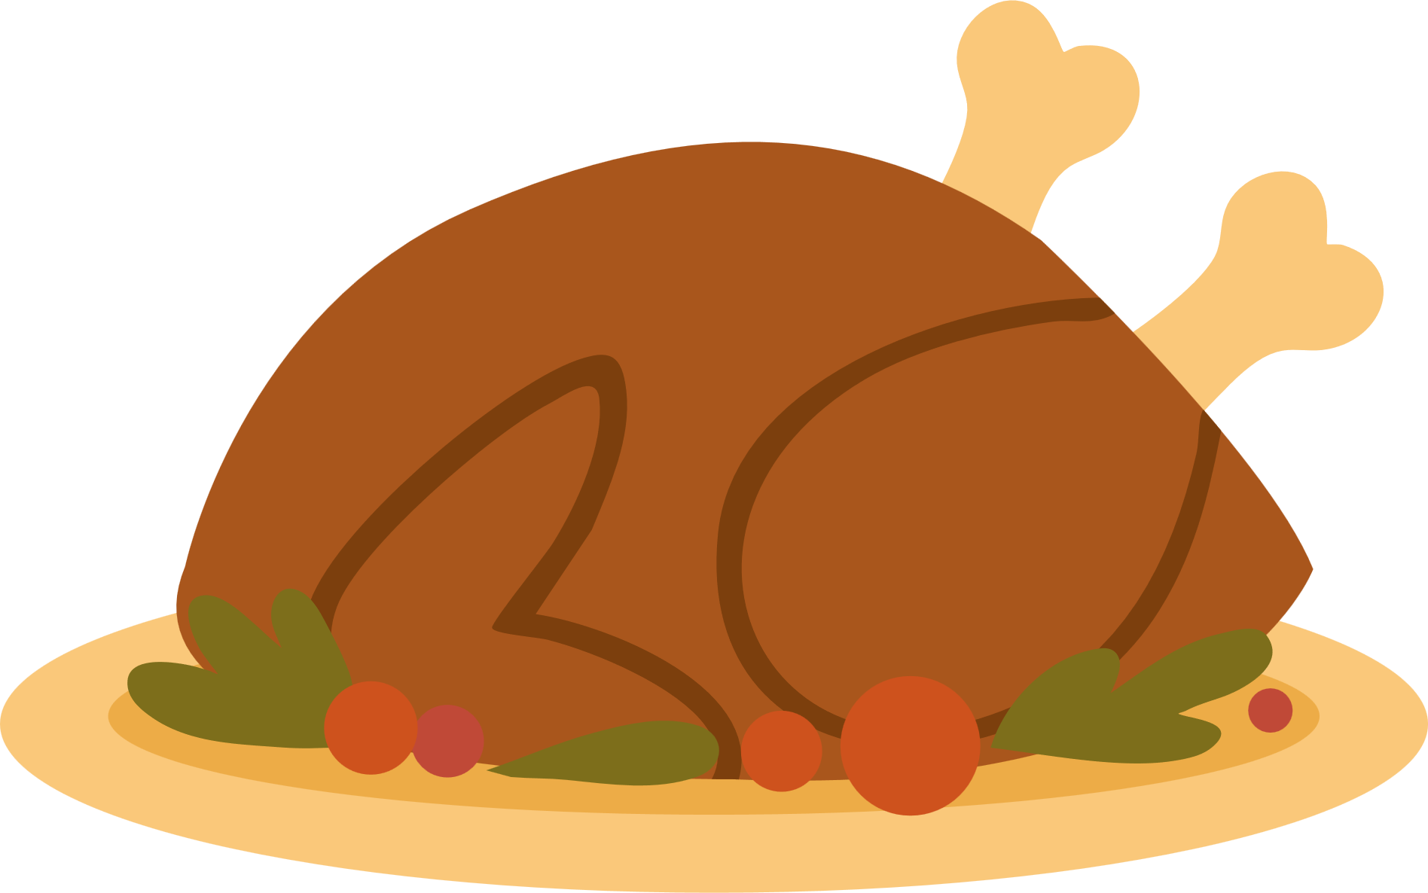
INGREDIENTS
- 3 cups leftover turkey, chopped
- 2 cups prepared stuffing
- 1½ cups leftover mashed potatoes
- 1 cup turkey gravy
- ½ cup shredded cheddar cheese
- 1 cup leftover vegetables
DIRECTIONS
- Preheat oven to 350°F.
- Spread turkey and vegetables in a greased casserole dish.
- Pour gravy over the top.
- Add the stuffing, followed by the mashed potatoes.
- Sprinkle with cheese.
- Bake for 30–35 minutes, until heated through and lightly golden.
RECIPE OF THE MONTH – Thanksgiving Leftover Casserole
These classic potato skins are warm, crispy, and easy to prepare. They make a great appetizer for football Sunday or a casual family get-together.
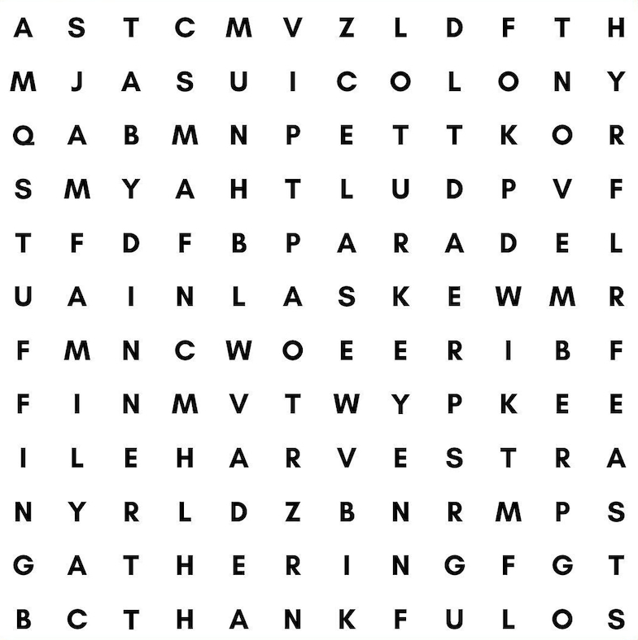
Colony
Harvest
Turkey
Parade
Mayflower
Family
Stuffing
Dinner
November
Gathering
Thankful
Feast
Thanksgiving
Word Search

Referrals | Page 4
NAME referred NAME
NAME referred NAME
NAME referred NAME
NAME referred NAME
NAME referred NAME
NAME referred NAME
NAME referred NAME
NAME referred NAME

I try hard to recognize every referral I am aware of, but if I have missed anyone please let me know. I want all of you to know that it is my privilege to serve you, and the greatest compliment you pay me is the referral of your family and friends. Thank you!

Personal Notes:


Insert personal notes here
Firstname Lastname
Agency Name
Office Phone: 000-000-0000
Email: email@website.com

