

June / July 26 Edition | First Name Last Name

Celebrating Summer & the Spirit of Fourth of July
June/July  Birthdays  Birthday Here  Birthday Here  Birthday Here  Birthday Here  Birthday Here  Birthday Here  Birthday Here  Birthday Here  Birthday Here  Birthday Here  Birthday Here   | As summer arrives with warm days in tow, there’s a special feeling in the air: longer evenings, sunshine-filled afternoons, and the joyful anticipation of gathering with friends and family. One of the highlights of the season is the Fourth of July, a time to celebrate our nation’s independence while enjoying the simple pleasures that summer brings.  For many of us, this holiday is filled with cherished traditions. The smell of burgers and hot dogs sizzling on the grill, the laughter of loved ones gathered in the backyard, and the sparkle of fireworks lighting up the night sky all come together to create lasting memories. Whether you’re hosting a cookout or attending a neighborhood gathering, summer is the perfect time to reconnect and relax.  Barbecues are a centerpiece of the season, and they don’t have to be elaborate to be enjoyable. Classic favorites like grilled chicken, corn on the cob, fresh salads, and juicy watermelon are always a hit. For those who enjoy cooking, trying a new recipe or adding a special twist to an old favorite can make the day even more fun.  Summer is also a wonderful opportunity to stay active in ways that feel good. A morning walk, an afternoon spent gardening, or simply sitting outside with a good book can lift your spirits and keep you engaged. Don’t forget to stay hydrated and protect yourself from the sun while enjoying the outdoors.  Most importantly, this time of year reminds us to slow down and appreciate the little things like good food, pleasant company, and the warmth of a beautiful summer day. Whether you’re watching fireworks, spending the holiday with loved ones, sharing stories around the table, or simply enjoying a quiet evening on the porch, this season offers something for everyone.    Wishing you a safe, happy, and fun-filled summer!

Birthdays  Continued  Birthday Here  Birthday Here  Birthday Here  Birthday Here  Birthday Here  Birthday Here  Birthday Here  Birthday Here  Birthday Here  Birthday Here  Birthday Here  Birthday Here  Birthday Here  Birthday Here  Birthday Here  Birthday Here  Birthday Here   | Summer Funnies  Page 2
 | (Please do not read if you are easily offended!)
Firework-related Jokes! We hope they spark a laugh!
- A police officer caught two kids playing with a car battery and a firework.
He charged one and let the other off.
- Jimmy’s firework display was a complete disaster. “I don’t understand it!” he said. "They all worked fine when I tested them yesterday."

- My wife asked if I knew why the neighbour’s house burned down. I shrugged and said, "Fireworks?" She replied, "Yes, sadly it does."
- We were driving past Epic Fireworks when my wife exclaimed, “Wow, that showroom is huge.” I replied, "Yeah, you just can’t hold a candle to that place."
- My wife said fireworks are a waste of money when there are people starving. I said, "Yeah, but blowing them up would be wrong."
- How are women similar to fireworks? They look great from a distance, dangerous up close, and can be set off by the tiniest spark.

A couple was enjoying a warm summer afternoon sitting on their front porch, watching the neighbors go by.
The husband says, “You know, this weather is perfect. Not too hot, not too cold… just right.”
His wife smiles and replies, “Yes, it’s the kind of day that makes you want to do absolutely nothing.”
He nods and says, “That’s funny—I had that same feeling yesterday!”

At a summer barbecue, a man was carefully tending the grill while his friend watched.
After a while, the friend asked, “How do you always get your burgers just right?”
The grill master replied, “It’s simple—I never rush, I keep an eye on things, and I enjoy the process.”
His friend laughed and said, “That sounds less like cooking and more like a life philosophy!”
The grill master smiled and said, “Well, good food and a good life both take a little patience—and maybe a little extra seasoning!”

Birthdays  Continued  Birthday Here  Birthday Here  Birthday Here  Birthday Here  Birthday Here  Birthday Here  Birthday Here  Birthday Here  Birthday Here  Birthday Here  Birthday Here  Birthday Here  Birthday Here  Birthday Here  Birthday Here  Birthday Here  Birthday Here | Fun Page | Page 3
(source: www.thepioneerwoman.com)
DIRECTIONS
- For the pie: Preheat oven to 375°F.
- Roll out pie dough and place it in a pie pan.
Decorate edges as desired.
- Add apple slices to a large bowl. In a separate bowl, mix together cream, ½ cup brown sugar, 1/2 cup sugar, 1 tablespoon flour, vanilla, and cinnamon. Pour over apples. Pour apples into pie shell.
- For the topping: In the bowl of a food processor (or you can mix by hand) combine butter, flour, sugar, pecans (chop if not using food processor), & salt. Mix until everything comes together in clumps and pour over apples.
- Attach foil to the edges and lay a piece of flat foil loosely over the top of the pie. Place pie pan on top of a rimmed cookie sheet and bake for 1 hour. At the end, remove foil and allow to finish baking and browning.
Can bake for up to 15 or 20 minutes more if necessary.
- Remove from oven when pie is bubbly and golden brown. Serve warm with whipped cream or ice cream. Enjoy!
FOR THE TOPPING:
For the topping:
7 Tbsp. butter
3/4 cup all-purpose flour
1/2 cup brown sugar
1/4 cup pecans
Dash of salt
INGREDIENTS
1 unbaked pie crust
3 large (or 4 or 5 small) Granny Smith apples, peeled, cored, & sliced thin
1/2 cup brown sugar
1/2 cup sugar
1 Tbsp. all-purpose flour
1/2 cup heavy cream
2 tsp. vanilla extract
1/8 tsp. cinnamon
RECIPE OF THE MONTH – Dreamy Apple Pie
SERVES: 12 | PREP TIME: ~20 minutes | COOK TIME: ~1 Hour

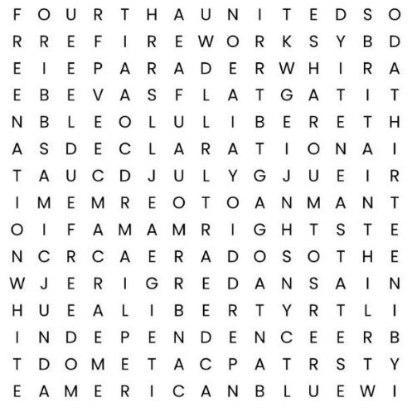
America
Blue
Britain
Declaration
Fireworks
Liberty
Nation
Parade
Red
Rights

Flag
Fourth
Freedom
Independence
July
States
Summer
Thirteen
United
White

Independence Day
Word Search

Referrals | Page 4
NAME referred NAME
NAME referred NAME
NAME referred NAME
NAME referred NAME
NAME referred NAME
NAME referred NAME
NAME referred NAME
NAME referred NAME

I try hard to recognize every referral I am aware of, but if I have missed anyone please let me know. I want all of you to know that it is my privilege to serve you, and the greatest compliment you pay me is the referral of your family and friends. Thank you!

Personal Notes:


Insert personal notes here
Firstname Lastname
Agency Name
Office Phone: 000-000-0000
Email: email@website.com

