
March 26 Edition First Name Last Name

2026 March Tips for seniors
Feb/March  Birthdays  Birthday Here  Birthday Here  Birthday Here  Birthday Here  Birthday Here  Birthday Here  Birthday Here  Birthday Here  Birthday Here  Birthday Here  Birthday Here   | March 2026: Taking Charge of Your Health This Spring  As we move into March and the start of spring, it’s the perfect time to refocus on your health and well-being. Even small steps can make a big difference in how you feel each day.  One of the most important things seniors can do is stay current with preventive care. This includes annual wellness visits, routine screenings, and managing any ongoing conditions such as high blood pressure, diabetes, or heart health. Preventive care helps catch potential issues early, when they are often easier to manage.  March is also a great time to become more active as the weather begins to improve. Walking, stretching, or light exercise can help improve mobility, balance, and overall energy levels. Even 15–20 minutes of activity a day can support better physical and mental health.  Mental well-being is equally important. Staying connected with friends, family, and community activities can help reduce feelings of isolation and support emotional health.  Finally, take time to review your medications and healthcare coverage to ensure everything still meets your needs. If you have questions, don’t hesitate to speak with your healthcare provider.  Taking a few proactive steps today can help you stay healthy, independent, and enjoying the things you love throughout the year.

Birthdays  Continued  Birthday Here  Birthday Here  Birthday Here  Birthday Here  Birthday Here  Birthday Here  Birthday Here  Birthday Here  Birthday Here  Birthday Here  Birthday Here  Birthday Here  Birthday Here  Birthday Here  Birthday Here  Birthday Here  Birthday Here   | March Funnies  Page 2
 | (Please do not read if you are easily offended!)
The Doctor’s Advice
An 82-year-old man went to his doctor for his annual checkup. After the examination, the doctor said, “You’re in excellent health. Is there anything you’d like to ask me?”
The man replied, “Actually, yes. After I got married last year, I noticed something. My new wife is 30 years younger than me, and she’s now pregnant. What do you think about that?”
The doctor paused, smiled, and said, “Let me tell you a story. I once knew a hunter who went out into the woods but accidentally grabbed his umbrella instead of his rifle. Suddenly, a bear charged at him. He pointed the umbrella at the bear, and — bang! — the bear fell over dead.”
The old man looked confused and said, “That’s impossible. Someone else must have shot the bear!”
The doctor nodded and said, “Exactly.”
The man thought for a moment… then slowly smiled.
Moral of the story: Sometimes, it’s best to enjoy the good news and not ask too many questions.

Technology Trouble

A senior gentleman bought a brand-new smartphone. He was very proud of it and decided to show it off to his friend at breakfast.
“My phone can do everything,” he said. “It tells me the weather, gives directions, and even answers my questions.”
His friend said, “Really? Ask it something.”
The man spoke into the phone, saying, “How old am I?”
The phone responded instantly: “You are 76 years old.”

His friend was impressed. “That’s amazing!”
The man smiled proudly and said, “Watch this.”
He asked the phone, “What happens when someone gets older?”
The phone replied, “Opening joke applications…”
The man quickly shut off the phone and said, “See? It’s still learning when to keep quiet.”

Birthdays  Continued  Birthday Here  Birthday Here  Birthday Here  Birthday Here  Birthday Here  Birthday Here  Birthday Here  Birthday Here  Birthday Here  Birthday Here  Birthday Here  Birthday Here  Birthday Here  Birthday Here  Birthday Here  Birthday Here  Birthday Here | Fun Page  Page 3
DIRECTIONS
- Preheat oven to 375°F.
- Place salmon on a baking sheet lined with foil or parchment paper.
- Drizzle olive oil over the salmon.
- Add garlic, lemon juice, salt, and pepper.
- Bake for 12–15 minutes, until salmon flakes easily with a fork.
- Sprinkle with parsley if desired.

INGREDIENTS

- 2 salmon fillets
- 1 tablespoon olive oil
- 1 teaspoon minced garlic
- Juice of ½ lemon
- Pinch of salt
- Pinch of black pepper
- Optional: fresh parsley

RECIPE OF THE MONTH
Easy Lemon Garlic Baked Salmon
SERVES: 2 | PREP TIME: 5 mins | COOK TIME: 15 mins
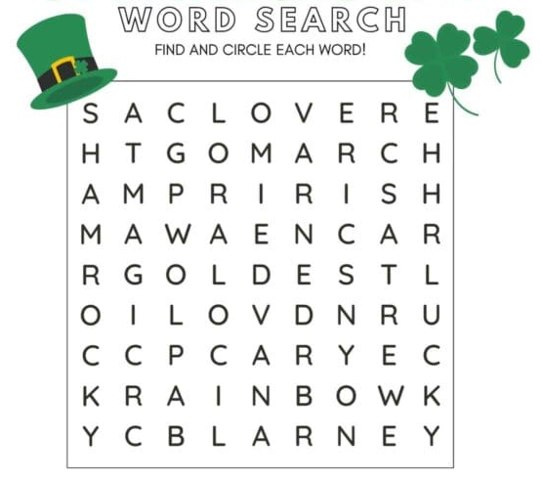
Word Search
Lucky
Shamrock
Gold
Green
Rainbow
March
Magic
Clover
Coins
Irish
St Paddy
Blarney

Referrals
Page 4
NAME referred NAME
NAME referred NAME
NAME referred NAME
NAME referred NAME

NAME referred NAME
NAME referred NAME
NAME referred NAME
NAME referred NAME
NAME referred NAME
NAME referred NAME
NAME referred NAME
NAME referred NAME

I try hard to recognize every referral I am aware of, but if I have missed anyone please let me know. I want all of you to know that it is my privilege to serve you, and the greatest compliment you pay me is the referral of your family and friends. Thank you!
Personal Notes:


Insert personal notes here
Firstname Lastname
Agency Name
Office Phone: 000-000-0000
Email: email@website.com

